Chapter 2

Linear Algebra

# **Table of contents:**

1. Scalars, Vectors, Matrices and Tensors
2. Multiplying Matrices and Vectors
3. Identity and Inverse Matrices
4. Linear Dependence and Span
5. Norms
6. Special Kinds of Matrices and Vectors
7. Eigen decomposition
8. Singular Value Decomposition
9. The Moore-Penrose Pseudoinverse
10. The Trace Operator
11. The determinant
12. Example: Principal Components Analysis

## **Scalars, Vectors, Matrices and Tensors**

Important terms:

* **Scalar: A single number**. Eg. Let $s∈R$ be the slope of the line, where s is our scalar value
* **Vector: A 1D array**. Eg. Let x be a vector of size (3x1) $x=\begin{matrix}x_{1} \\ x_{2} \\ x_{3}\end{matrix}$
* **Matrix: A 2D array**
* **Tensor: A 3D or 3D+ array.**
* **Transpose: Taking mirror image across main diagonal.** Eg. 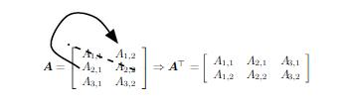
* **Broadcasting: Implicit copying of scalar/vector value to a matrix**